SimBionic Dynamic Scripting Example
Jeremy Ludwig
Last Updated: 05/05/2008

A SimBionic project and corresponding JUnit test have been created to graphically design a dynamic scripting choice point, initialize a SimBionic engine, and then run a number of behaviors that demonstrate the use of choice points. These tests are found in the test/ folder under the com.stottlerhenke.dynamicscripting package.

Sample SimBionic Project
The Sample SimBionic Project (Sample.sbp) is included in the testing package. There are three different behaviors. The main behavior uses dynamic scripting to generate a single
script and then make a number of selections (with no reward).

NOTE: When creating you own choice points in SimBionic, you must define two actions in the SimBionic editor: “chooseDS” and “Reward”. As a behavior author, you will need to completely define “Reward” and you can call it whatever you like (e.g. “rewards”). However, the choice point MUST be called “chooseDS”. You do not need to provide any implementation for the chooseDS action.

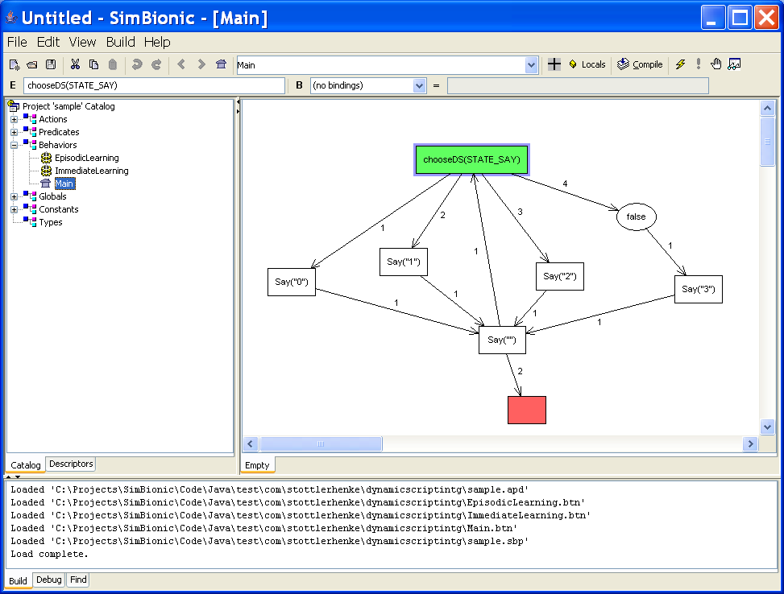

The other two behaviors demonstrate immediate
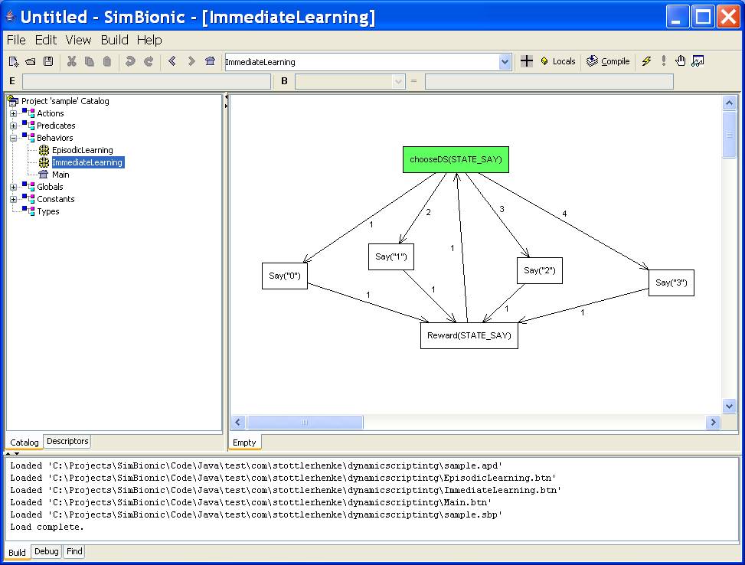

or episodic rewards.

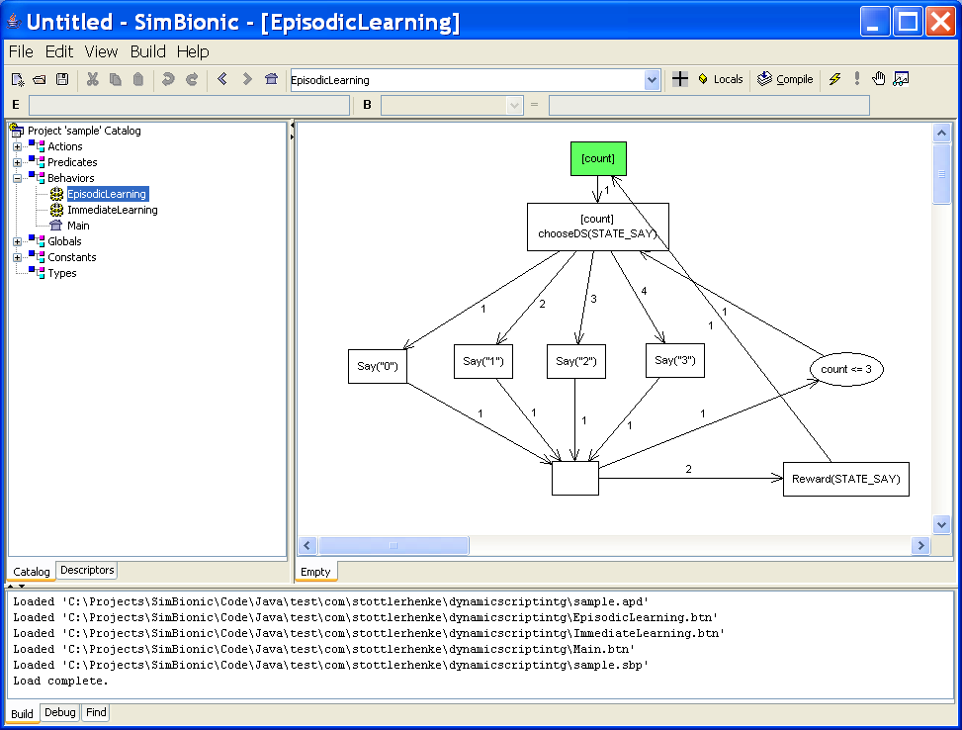

JUnit Test

DS_Interface
The DS_Interface class implements the actions and predicates defined in the SimBionic behavior file. In this case, that consists of the Say and Reward actions. The Say action keeps a tally of the actions selected by SimBionic. The Reward action turns the tally into a specific reward value and then sends the reward to the appropriate choice point.

In the case where you are building off of this example, you will need to write a separate interface that implements all of the desired actions and predicates for your specific simulation. Additionally, you will need to implement a Reward method that makes the following call:

DynamicScriptingWrapper.getInstance().rewardChoicePoint(choicePointId, reward);

Failure to do this means that no learning will occur.

DS_SB_Test
The DS_SB_Test provides examples on how to create choice points in the method createChoicePoints(). You need to create a DsAction object for each transition available form a choice point, with an index of 0 in a DsAction corresponding to the transition labeled 1 in a SimBionic diagram. The initial value assigned to an action is also important and needs to be tuned. Once you have a list of action objects, you can create a choice point. When creating a choice point, you will need to tune the size of the subscript and the minimum/maximum allowed action values.

The second important method in this class is initializeSBEngine. This method shows how to start the SimBionic engine.

Finally, the three test methods show how to create a SimBionic entity with a particular behavior and execute the behavior some number of times. Given the cyclic nature of the example behaviors, they require one update for each transition (i.e. they are NOT one-tick behaviors).

